DEVIZES RUGBY FOOTBALL CLUB

Affiliated member of
Dorset & Wilts. RFU
Member of the RFU
and England Rugby

Chairman President Secretary Mark Shepperd Mark Hill Keith Butler

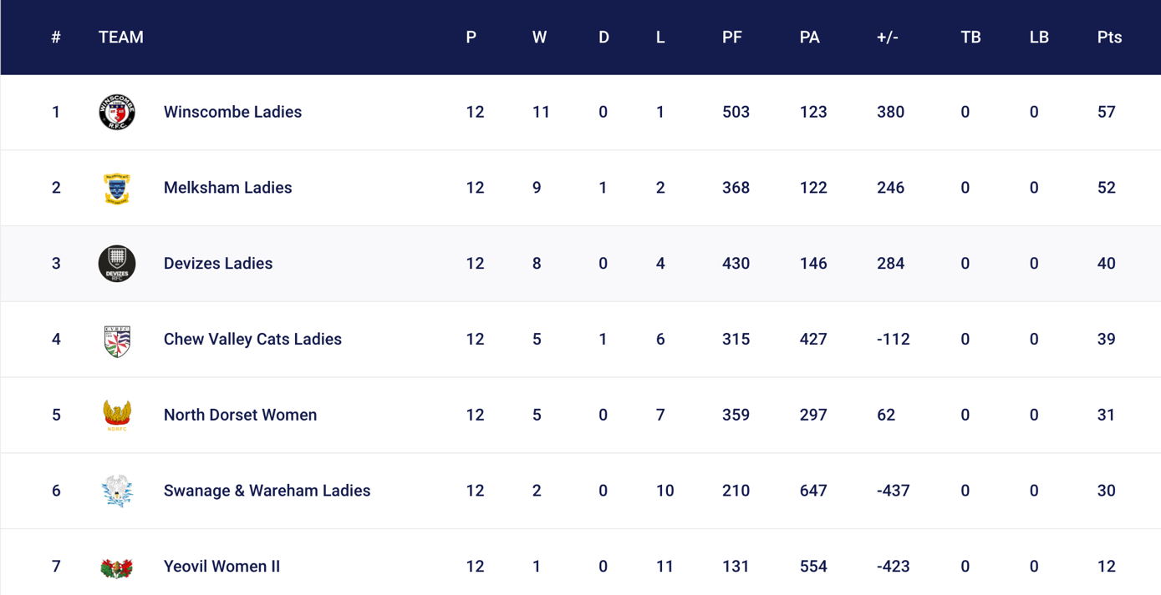
LADIES SECTION REVIEW- MAY 2025

Reflecting on the season and the league table above, Devizes Ladies are proud to have secured 3rd place in the NC2 South West (South) league. At our pre-season meeting, the team set a goal of finishing in the top three; based on our performance the previous season, we felt this was within reach. We're delighted to have achieved that target. Over the course of the season, we recorded 8 wins, including 4 clean sheets where we didn’t concede a single point. Of our four losses, one was an away walkover due to being unable to field a travelling side, and two were against Winscombe, who finished top of the table and earned promotion to NC1.
In total, we scored 430 points and conceded 146. Our home game performance improved notably from last year, with 100 more points scored and a similar number of points conceded. Our away performance remained consistent with the previous season. This improvement is likely a reflection of our players’ growing confidence and experience, with many now completing their second or third season of competitive rugby, as well as a stronger grasp of team calls and communication. The increasing support from fans, both at home and away, has also boosted team morale and performance.
A standout achievement this season was the individual performance of our players. On-field captain Denny Jones led the way with 15 tries securing top point scorer in the league, closely followed by fly-half Sophie Spillane with 12, securing third! Both players also finished among the top five try scorers in the league. A fantastic accomplishment that makes the entire squad proud! As a team, we also topped the league for most points scored at home and third for points scored in away games. One of the most memorable highlights was our biggest win of the season: an 86–0 away victory over Swanage & Wareham, achieved despite travelling with a reduced squad. This was made memorable for Devizes Rugby Club as we travelled with the Men’s 1st XV, who also secured a win.
Finishing third in the league is a significant milestone for Devizes Ladies, especially considering the challenges we faced, including losing several experienced players to injury. This season has been a testament to the team’s determination, resilience, and growth and we’re excited to see what next season brings.
This season brought new challenges and fresh competition for Devizes Ladies in the NC2 league. While we faced some familiar teams from previous seasons such as Yeovil, Swanage & Wareham, and Chew Valley, we also met determined and competitive opposition. Winscombe proved to be a dominant force and ultimately topped the league, while Melksham showcased a large and strong team side, eager to lead the season.
Devizes Ladies got off to a flying start, winning our first three matches and claiming the top spot early on. One of the most hard-fought games of the season came against Winscombe away, where both teams displayed exceptional defensive efforts. The game remained close until the final minutes, when a late try from the opposition handed us a narrow and tough defeat. We were fortunate to have seven teams in our league this year, though not all could consistently field a side. Our team managers worked tirelessly to rearrange fixtures rather than accept walkovers, prioritising game time and player development. This commitment allowed us to apply skills developed in training to match situations, something the squad greatly valued. Remaining in NC2 next season offers a strong opportunity for growth. With the anticipated return of key players currently sidelined by injury, we believe the team will be well-positioned to dominate and potentially challenge for promotion to NC1.
In terms of player base, we had 26 registered players for the 2024/25 season. We had five players who were only available for part of the season due to prior commitments like travel and therefore paid half-season membership. While new player intake was limited, we were grateful for the support from neighbouring clubs via dual registrations. This helped ensure fixtures could go ahead when numbers were tight. Injuries played a significant role this season, with multiple players including our elected captain, Chloe Hounslow. The absence of experienced individuals created opportunities for newer players to step up. These players trained hard, adapted quickly, and delivered strong performances on game day. The team has maintained a welcoming and supportive environment, helping integrate new and dual-registered players, practicing positional techniques and has contributed to positive player retention.
Team spirit remained high throughout the season, regardless of match results. The players consistently demonstrated enthusiasm, camaraderie, and commitment to supporting one another. We also celebrated achievements at the county level, with both our captain and vice-captain selected to represent Dorset & Wiltshire. Denny Jones was chosen to lead the county squad, a remarkable achievement for both her and the club.
This season marks the end of an era as Keith steps down from his role after eight dedicated years coaching Devizes Ladies. His knowledge, support, and commitment have been invaluable, and he will be deeply missed. We thank him sincerely for everything he has contributed. We’re pleased that Abi will continue with the team next season, joined by Gareth, a highly experienced coach who also leads the Dorset & Wilts women’s squad. His passion for developing the women’s game will undoubtedly have a significant and positive impact on our squad.
Sadly, we’ll also be saying goodbye to coach Ben Biss. Ben brought expertise, especially in coaching our backs in both attack and defence and was a consistent presence on match days. He’s been a fantastic asset to the team and will be greatly missed. Helen, our hardworking Ladies Secretary, will be stepping down at the end of this season. Her responsibilities will now be absorbed into the role of the Ladies Chair. We’re hugely grateful for all her efforts and support behind the scenes.
Looking ahead, our social reps for the 2025/26 season have already begun planning, with a team campout on the horizon and early discussions around a rugby tour in 2026. The upcoming pre-season will officially begin with a players’ meeting on 27th June 2025, followed by the first training session on 16th July 2025. Our team managers are also arranging pre-season friendlies, with Supermarine Ladies among the clubs likely to be approached.
Looking forward, the 2025/26 season promises continued growth, renewed strength with returning players, and a positive trajectory toward promotion. The ongoing support from the club and our community will be essential in helping us reach those goals and is always deeply appreciated.

